The Fe(II) oxidation kinetics in the North Atlantic Ocean

Iron is an essential micronutrient for organisms (Martin et al., 1991), playing a key role in the biochemistry and physiology of oceanic phytoplankton (Sunda et al., 1991). Iron exists in two redox states, ferrous (Fe(II)) and ferric (Fe(III)). Each species exhibits different chemical characteristics. Iron(II) is very soluble, but is rapidly oxidized in the presence of oxygen. Fe(III) is the thermodynamically stable species in natural waters, but it can be reduced to Fe(II) under the influence of light (Miller et al., 1995) and microorganisms causing the formation of a significant steady state concentration of Fe(II) in surface waters (Laglera and van den Berg, 2007). The different inputs, chemical reactions, biological uptake and remineralization processes modify Fe concentrations, redox and aggregation state (Ye et al., 2009). These changes in the Fe speciation make Fe concentration difficult to measure and therefore the determination of Fe residence time in the sunlit surface ocean, where it can be used by phytoplankton, is complex.

Furthermore, not all Fe forms in seawater are equally available for phytoplankton uptake (Hudson et al., 1990). The concentration of dissolved Fe(II) in the photic zone and in deep waters depends on the Fe(II) oxidation rate (González-Davila et al., 2005; Santana-Casiano et al., 2005). The oxidation rate of Fe(II) controls, in part, the steady-state concentration of Fe(II) and, as a consequence, the bioavailable Fe pool.

The Fe(II) oxidation kinetics has been studied in seawater of the North Atlantic Ocean. The spatial distribution of the samples affected the oxidation rate of Fe(II) due to the chemical characteristics of each water mass sampled. Faster Fe(II) oxidation rates were observed within the chlorophyll maximum, in surface and coastal samples than in deep waters related with the remineralization state of the organic matter.

The studies of Fe(II) oxidation kinetics in natural conditions carried out in the Subarctic North Atlantic and in the Labrador Sea show that temperature, pH and salinity were the master variables controlling the Fe(II) oxidation kinetics. However, the sources and characteristics of the organic matter present were important factors influencing the oxidation of Fe(II), displaying both positive and negative effects on the Fe(II) oxidation rate. A general equation for the oxidation rate was obtained which allows computation of Fe(II) oxidation rate taking into account the effects of temperature, pH and salinity under natural conditions for the Subarctic North Atlantic and Labrador Sea. And a novel approach was applied to the oxidation kinetics of Fe(II) in the Labrador Sea, which allowed to determine the average contribution of the organic matter over the inorganic effect.
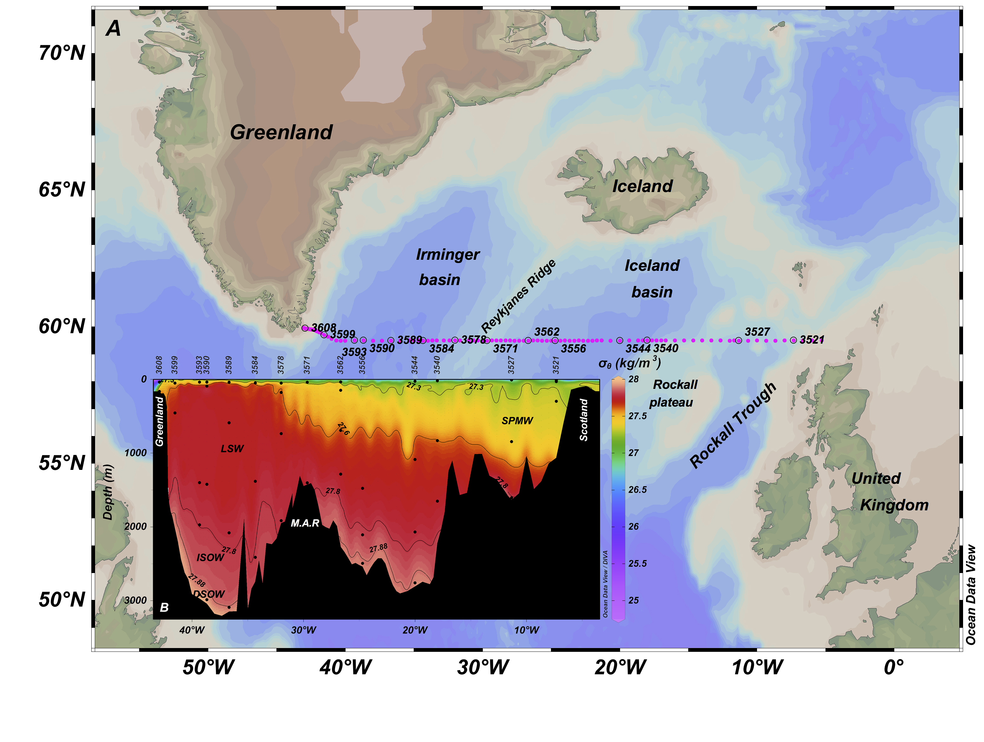

González-Davila, M., Santana-Casiano, J.M. and Millero, F.J., 2005. Oxidation of iron (II) nanomolar with H₂O₂ in seawater. Geochimica et Cosmochimica Acta, 69(1): 83-93.
Hudson, R.J., Morel, F.M. and Morel, F., 1990. Iron transport in marine phytoplankton: Kinetics of cellular and medium coordination reactions. Limnol. Oceanogr, 35(5): 1002-1020.
Laglera, L.M. and van den Berg, C.M.G., 2007. Wavelength Dependence of the Photochemical Reduction of Iron in Arctic Seawater. Environmental Science & Technology, 41(7): 2296-2302.
Martin, J.H., Gordon, M. and Fitzwater, S.E., 1991. The case for iron. Limnology and Oceanography, 36(8): 1793-1802.
Santana-Casiano, J.M., González-Dávila, M. and Millero, F.J., 2005. Oxidation of nanomolar levels of Fe (II) with oxygen in natural waters. Environmental science & technology, 39(7): 2073-2079.
Sunda, W.G., Swift, D.G. and Huntsman, S.A., 1991. Low iron requirement for growth in oceanic phytoplankton. Nature, 351(6321): 55.
Ye, Y., Völker, C. and Wolf-Gladrow, D.A., 2009. A model of Fe speciation and biogeochemistry at the Tropical Eastern North Atlantic Time-Series Observatory site. Biogeosciences, 6(10): 2041-2061.

